Factor analysis PPT and report resources:

Flow plot for cluster logic thought:

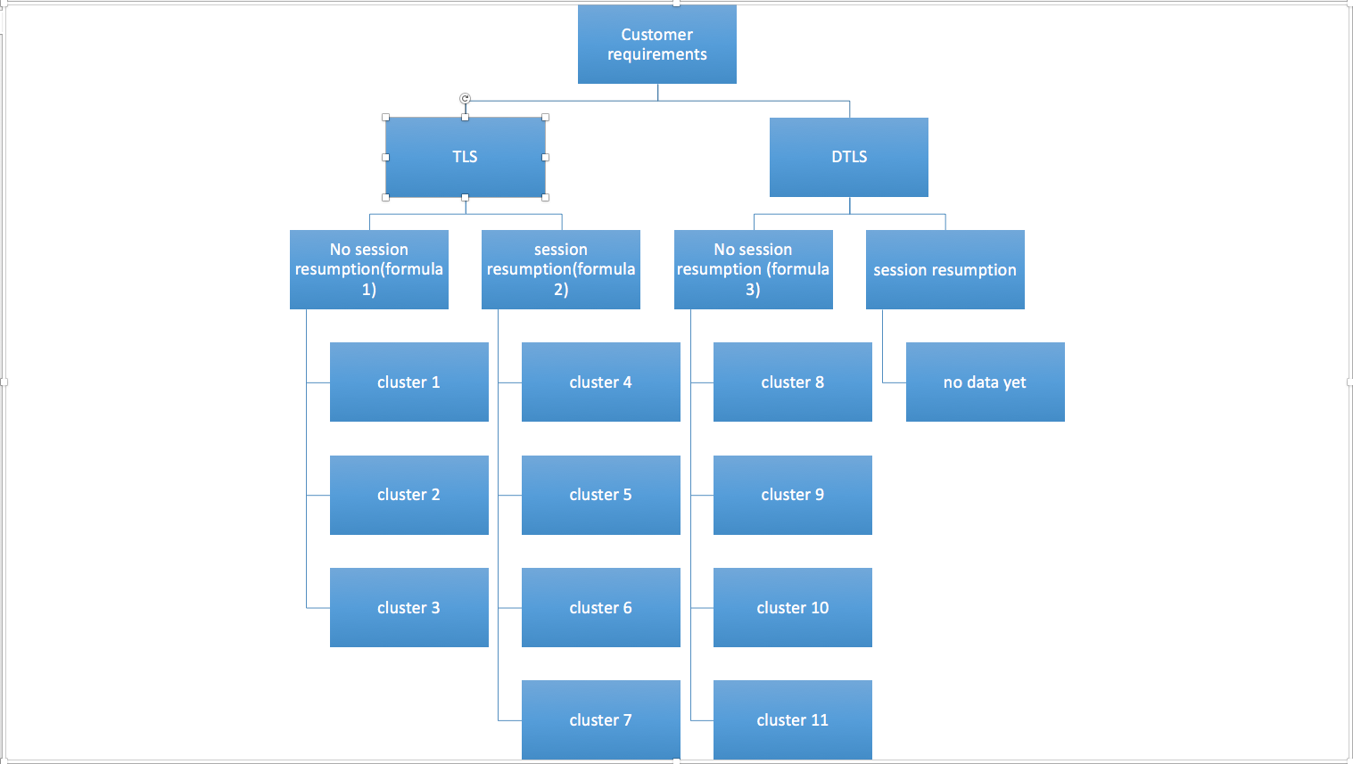

Factor analysis for cluster1, cluster2 and cluster3.

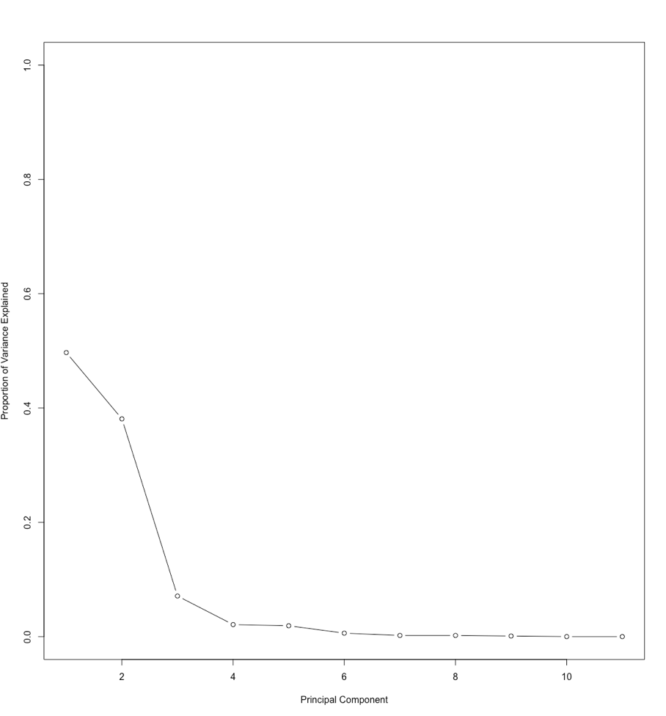



K-means cluster outcome:

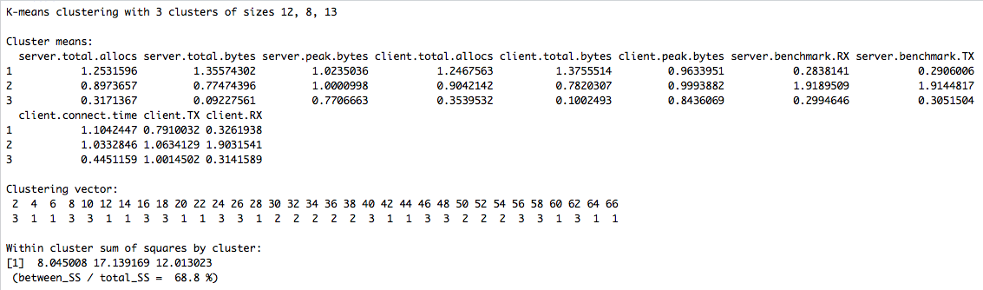

tree plot for classification:

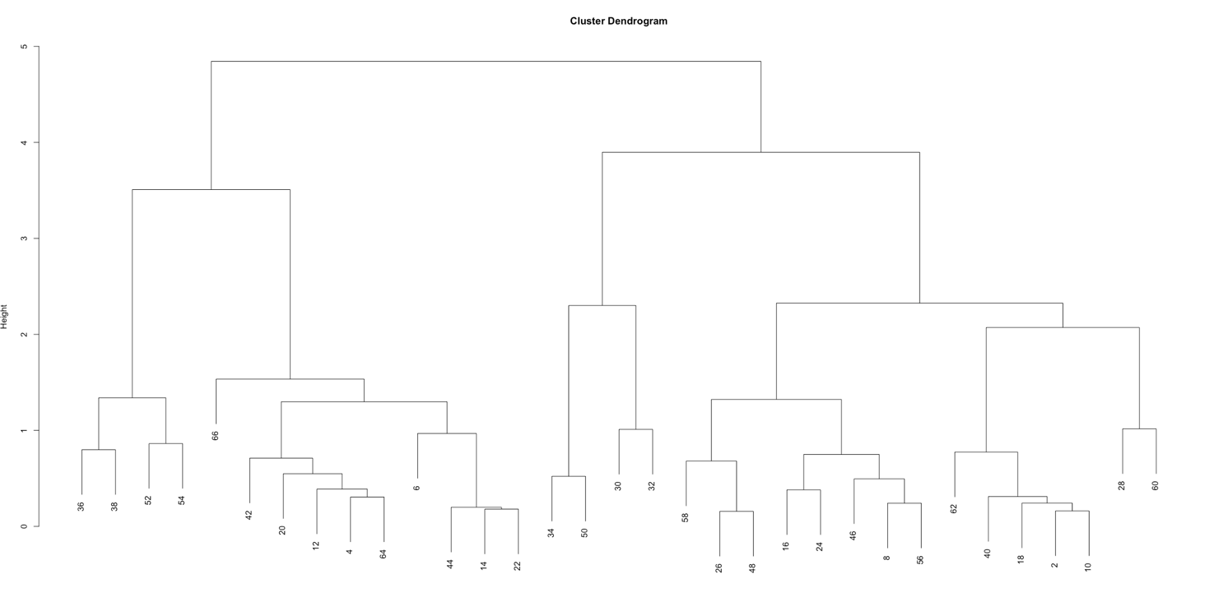

factor analysis for cluster 4- cluster 7

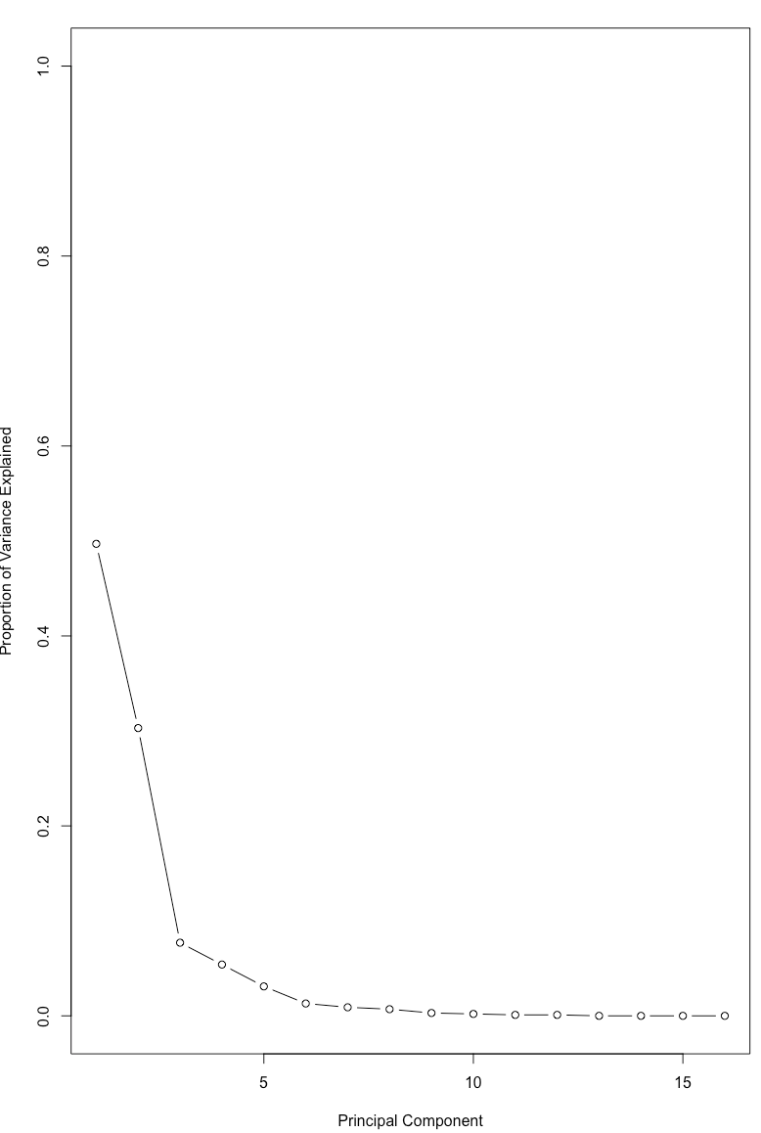



k-means outcome

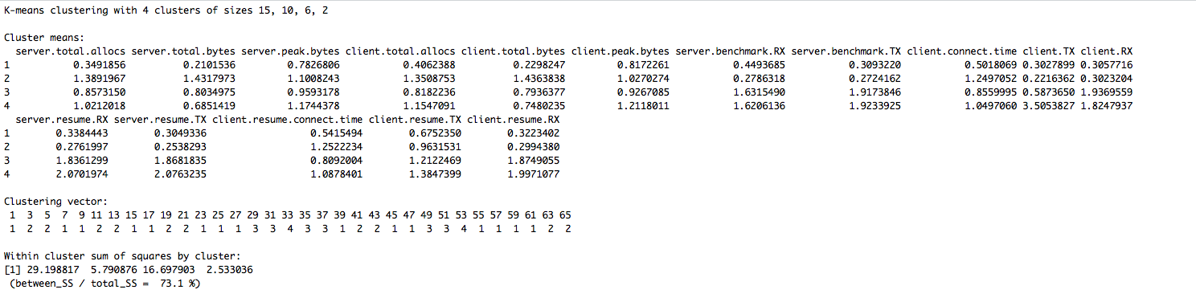

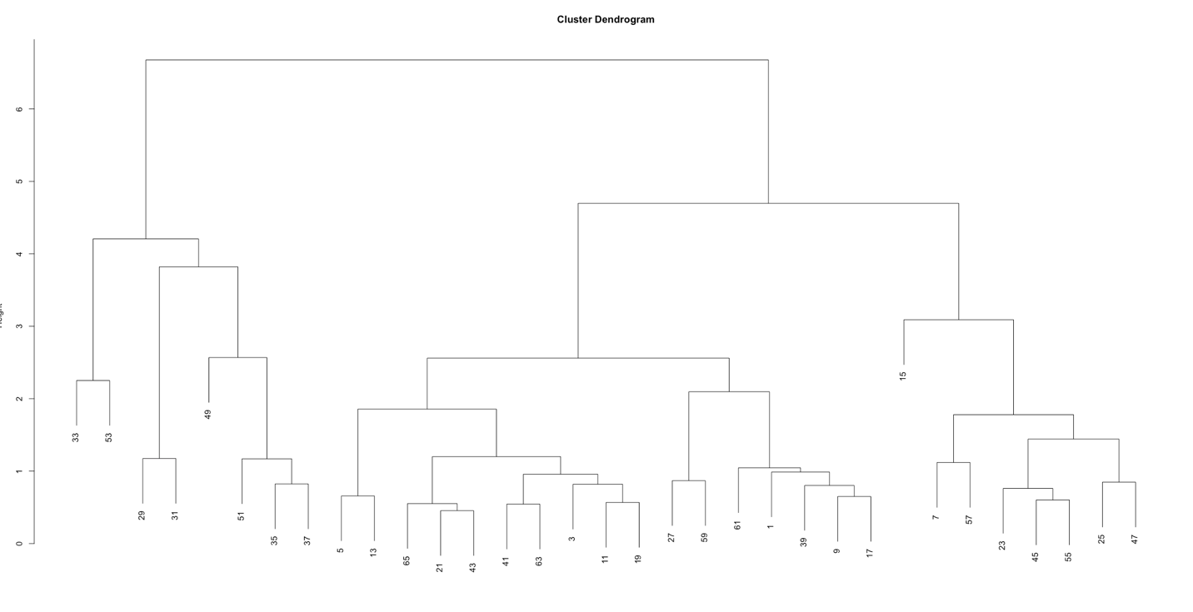

tree-based plot for factor-analysis

Cluster 8 – Cluster 11

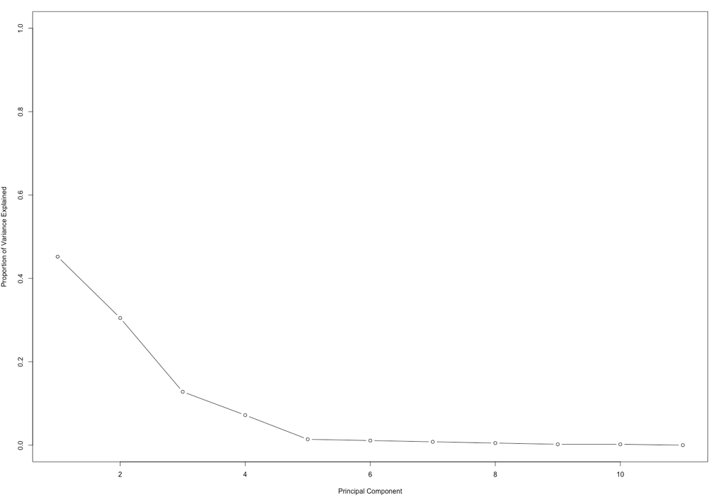



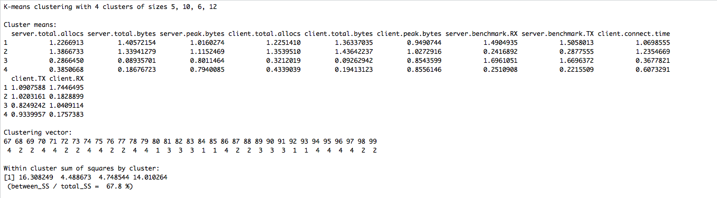

tree-based plot

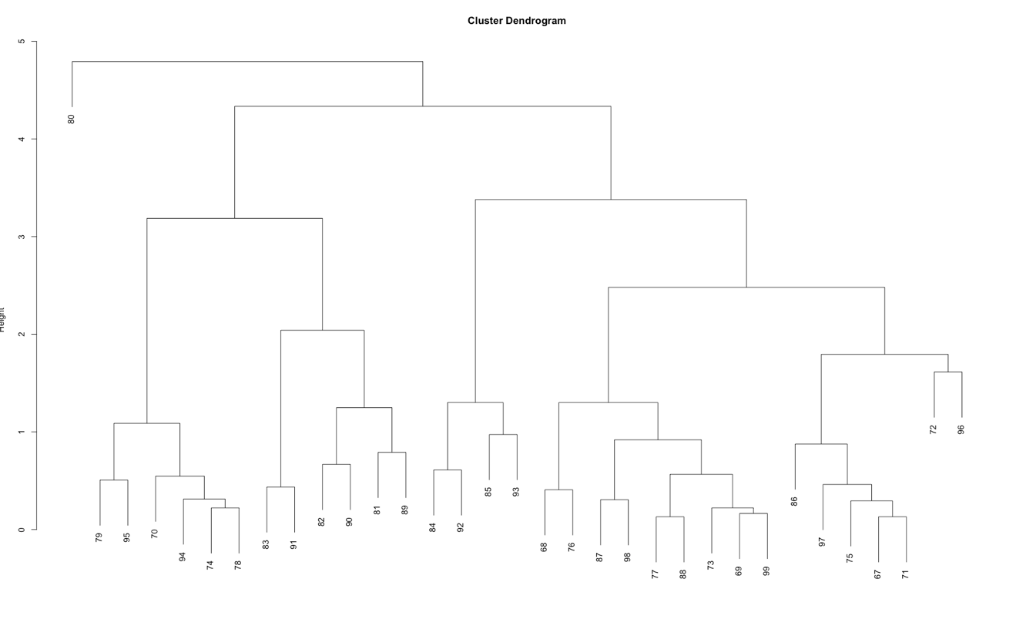

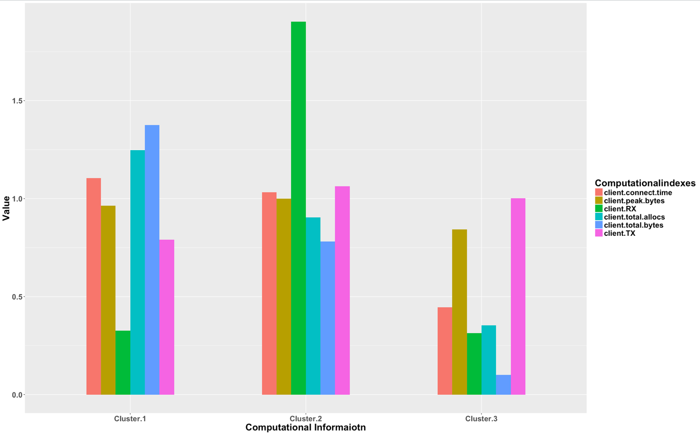

cluster 3 is the best one for IoT devices, which has small storage space and needs comparably fast receive as well as transfer speed.

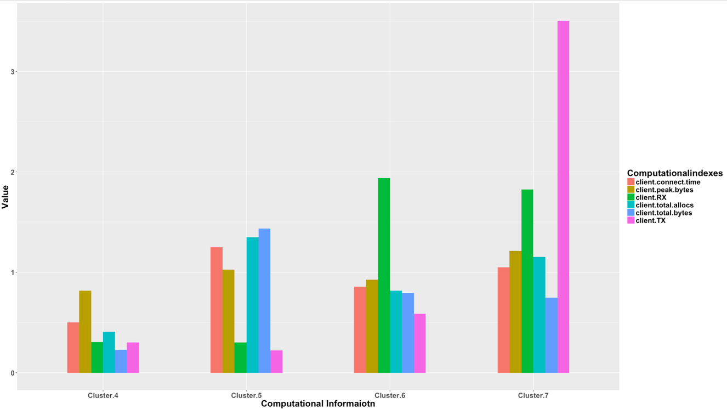

from the bar plot above, we can see that for IoT devices the best cluster is the 4th one, since it has lowest CPU RAM needs, and fastest receive and transfer speed.

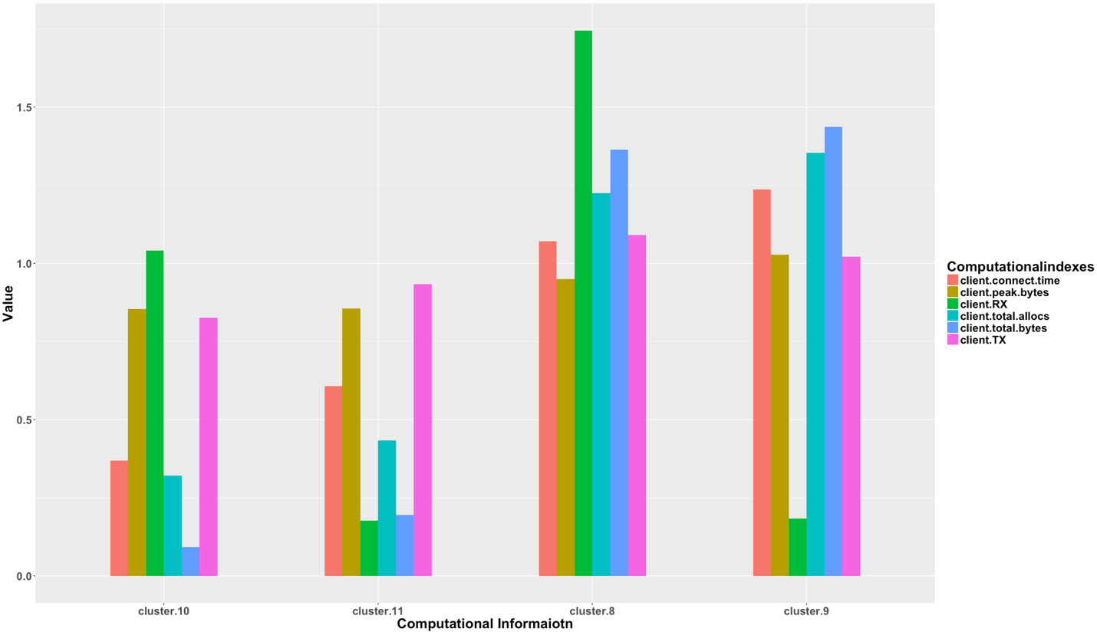

from the bar plot above, we can see that for IoT devices the best cluster is the 11th one, since it has lowest CPU RAM needs, and fastest receive and transfer speed.

Since the professor hopes our team’s work can combine with the 1st team, so the main data would be in multimedia type. So DTLS will be better than TLS, if the user needs to have more security power, he or she can choose “no session resumption part”, the 11th cluster is the best plan for IoT devices, so our formula selection will focus on cluster 11.

